* **Title Page: cs 1011-051 – Lab 8 <*Parking Lot Project*>**
* <Denise Malisa>
* <2/11/2020>
* <Page Break>
* **I. Objectives**

The purpose of this lab is to create a parking lot and its functions like the time vehicles enter and leave and the number of vehicles that occupy the space of the lot. Each lot has a different name and capacity. For each lot the number of vehicles present inside the lot is found, the time of entry for each car is recorded as well the time of exit. The time in which no car enters or leaves is recorded as well. For each parking lot there is a specific number of cars reached where the gate will be closed so that drivers don’t waste time and fuel looking for parking spaces as there will only be a few left. However, drivers are allowed to ignore that and search for that remaining 20% of parking spaces that are empty. District is a class that will store a number of these parking lots, each that behave the same as the individual one from ParkingLot.

* **II. Requirements**

The requirements of this lab were for me to try to understand the code that has been implemented by the design team and implement what is required of me by creating the District and ParkingLot classes. They have provided UML diagrams for guidance in helping me navigate writing the program.

The parking Driver class was given to enable me to be able to effetely test my classes to see that they are returning the values and output that is required by the design team**.**

* **III. Design:**

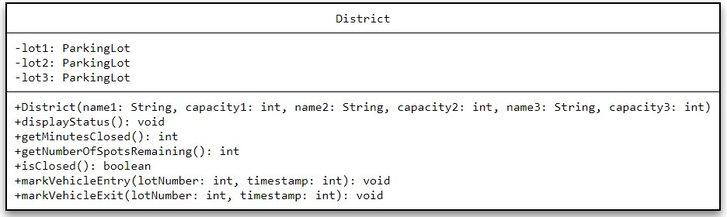

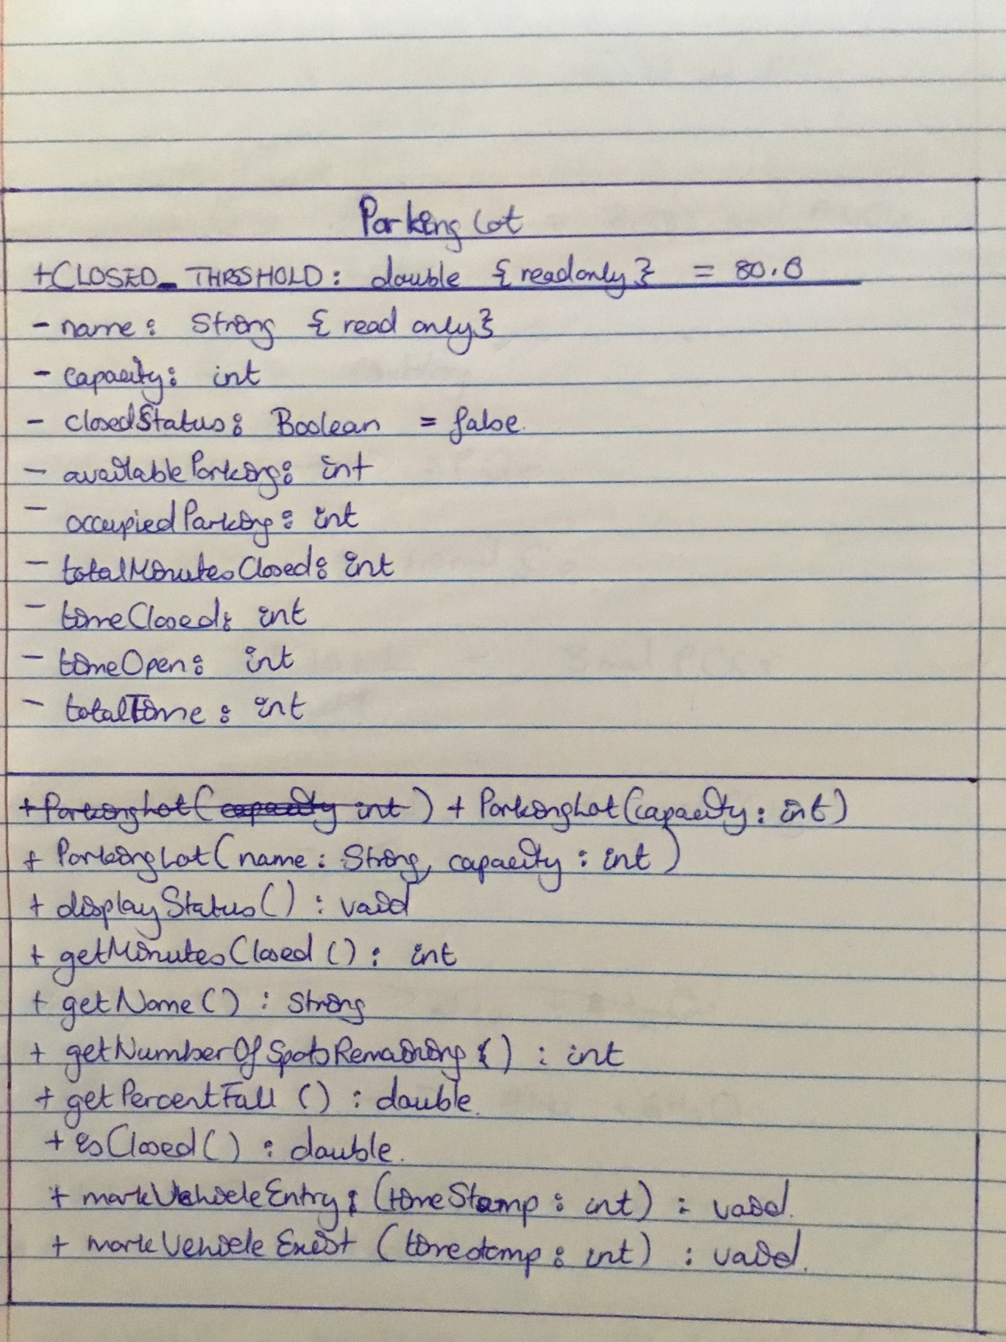

* **III. Test Plan/Test Strategy**

The ParkingLotDriver class was used to check for errors and wrong values for both Classes.

* **IV. Results**

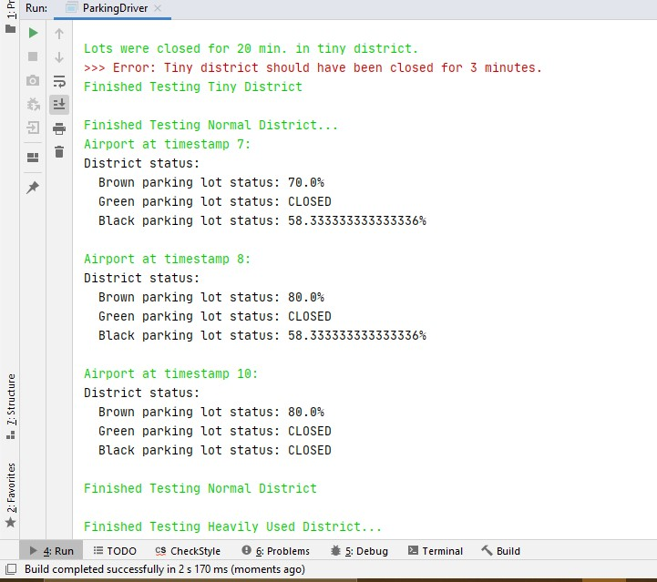

After looking into the district class at specific method like get minutes closed, mark entry and mark exit, with a little guidance to gain more understanding I was able to fix the error I had.

* **V. Discussion**

I struggled to understand the way timestamp worked in some instances I had the wrong calculations. It is supposed to take in the timestamp for when the gate is closed but it isn’t. I have timestamp errors which then affected my time in District class. It was difficult to correct some things because you’d correct one thing then something else would start presenting errors.